R Output
> library(NCStats)
> library(MASS)
> ss <- read.table("SalmonSperm.txt",head=T)
> str(ss)
`data.frame': 14 obs. of 3 variables:
$ step.len : num 2.48 2.94 3 3.02 3.17 3.18 3.2 3.27 3.31 3.66 ...
$ fert.succ: num 13.5 3 2.2 7 7 13.5 10.4 6.7 12.8 1.8 ...
$ mat : Factor w/ 2 levels "Adult","Parr": 1 2 2 1 2 1 1 1 1 ...
> xlbl <- "Sperm Tail End Piece Length (um)" # to save typing later
> ylbl <- "Fertilization Success"

> plot(ss$fert.succ~ss$step.len,pch=19,col=as.numeric(ss$mat),
+ xlab=xlbl,ylab=ylbl)
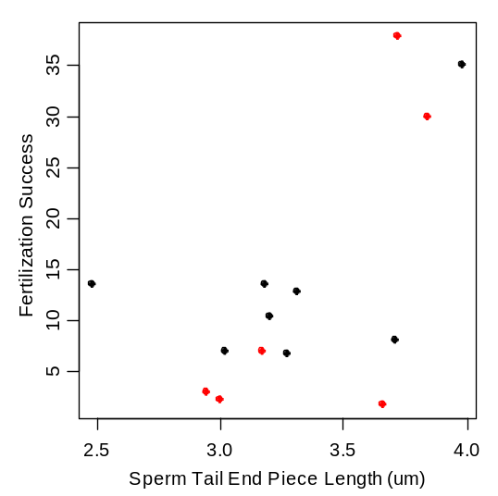
> identify(ss$fert.succ~ss$step.len)
[1] 1 10 11

> ss1 <- ss[-c(1,10,11),] # removed three outliers for simplicity
> plot(ss1$fert.succ~ss1$step.len,pch=19,col=as.numeric(ss1$mat),
+ xlab=xlbl,ylab=ylbl)
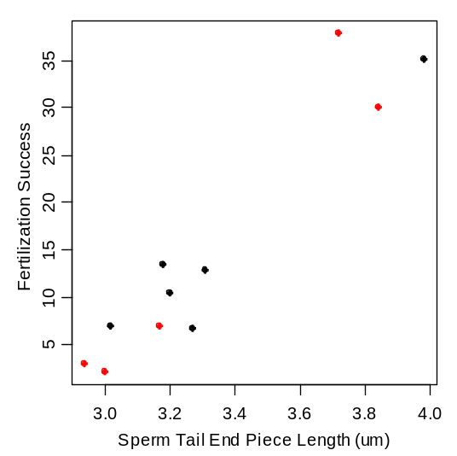
> attach(ss1)
> lm1 <- lm(fert.succ~step.len)
> summary(lm1)
Call: lm(formula = fert.succ ~ step.len)

Coefficients:
Estimate Std. Error t value Pr(>|t|)
(Intercept) -100.205 13.015 -7.699 3.00e-05 ***
step.len 34.610 3.889 8.901 9.35e-06 ***

Residual standard error: 4.366 on 9 degrees of freedom
Multiple R-Squared: 0.898, Adjusted R-squared: 0.8866
F-statistic: 79.22 on 1 and 9 DF, p-value: 9.35e-06

> plot.fit(lm1,xlab=xlbl,ylab=ylbl)
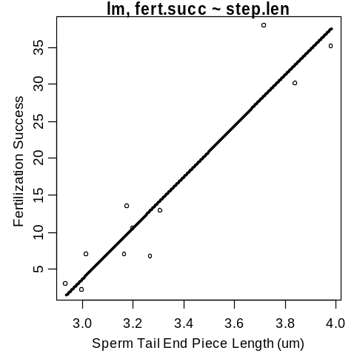

> predict(lm1,data.frame(step.len=3.5))
[1] 20.92912
> plot.fit(lm1,xlab=xlbl,ylab=ylbl,interval=”both”)
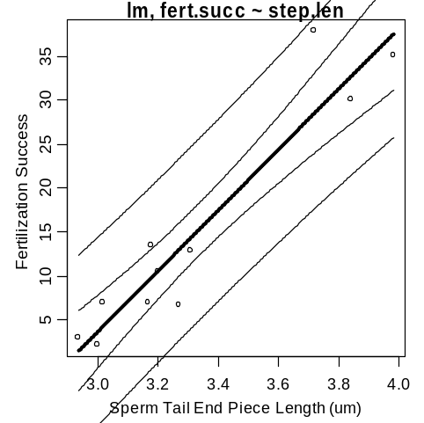

> predict(lm1,data.frame(step.len=3.5),interval="c")
fit lwr upr
[1,] 20.92912 17.5967 24.26153
> predict(lm1,data.frame(step.len=3.5),interval="p")
fit lwr upr
[1,] 20.92912 10.50502 31.35321
> plot.predict(lm1,data.frame(step.len=c(3.3,3.5)),interval="p",
+ xlab=xlbl,ylab=ylbl)
obs step.len fit lwr upr
1 1 3.3 14.00716 3.687506 24.32682
2 2 3.5 20.92912 10.505016 31.35321
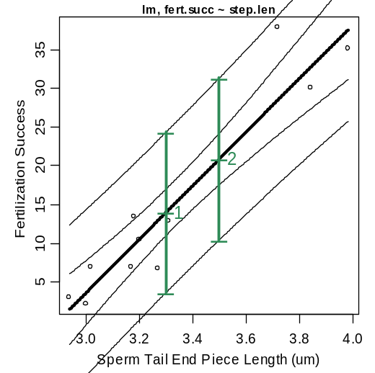

> anova(lm1)
Analysis of Variance Table
Response: fert.succ
Df Sum Sq Mean Sq F value Pr(>F)
step.len 1 1510.23 1510.23 79.22 9.35e-06 ***
Residuals 9 171.58 19.06

> plot.resid(lm1)
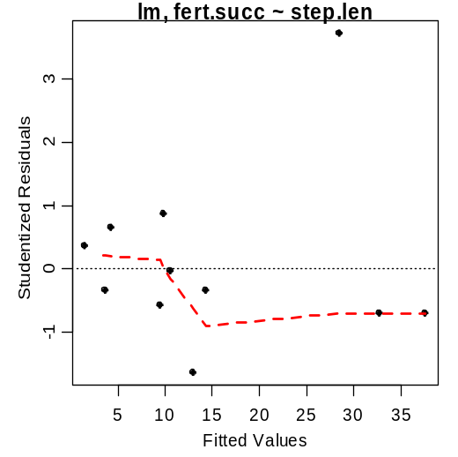
> ncv.test(lm1)
Non-constant Variance Score Test
Variance formula: ~ fitted.values
Chisquare = 1.655409 Df = 1 p = 0.1982243

> ad.test(lm1$residuals)
Anderson-Darling normality test
data: lm1$residuals
A = 0.4022, p-value = 0.2962

> hist(lm1$residuals) # not shown to save space
> outlier.test(lm1)
max|rstudent| = 3.717896, degrees of freedom = 8,
unadjusted p = 0.005889166, Bonferroni p = 0.06478083
Observation: 9
> plot.diag(lm1)
1 predictors and 11 individuals

Unusual Observation Results
measure value cutoff inf obs
1 |Studentized Residuals| 3.71790 NA FALSE 9
2 Leverage 0.42601 0.54545 FALSE 11
3 |COVRATIO-1| 0.94606 0.54545 TRUE 11
4 Cook's Distance 0.76476 0.44444 TRUE 9
5 |DFFits| 1.92581 0.94281 TRUE 9
6 Slope DFBetas 1.45429 0.60302 TRUE 9
7 Intercept DFBetas 0.51691 0.60302 FALSE 11

Data for Highlighted Individuals
obs fert.succ step.len
9 9 37.8 3.72
11 11 35.1 3.98
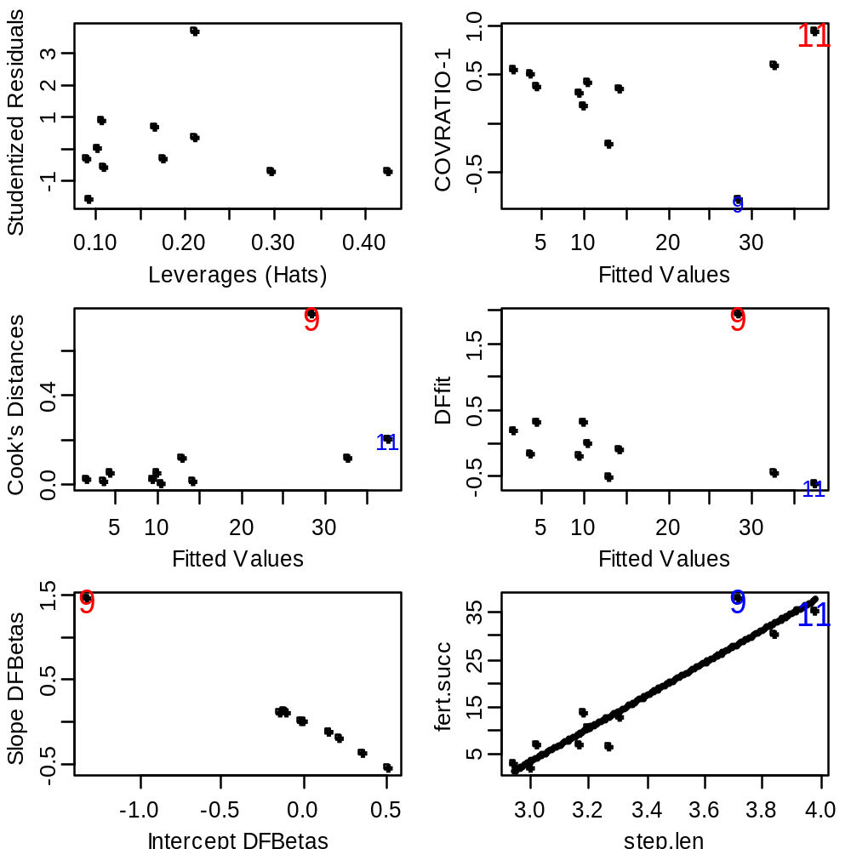

> library(NCStats)
> library(MASS)
> petrels <- read.csv("petrels.csv",head=T)
> str(petrels)
`data.frame': 19 obs. of 4 variables:
$ species : Factor w/ 13 levels "Diomedea chrysostoma",..: 2 2 ...
$ sex : Factor w/ 4 levels "both","female",..: 3 2 3 2 3 2 ...
$ weight : int 10577 9022 3922 3694 3751 3624 3305 3000 2996 ...
$ weight.loss: num 0.0087 0.0096 0.013 0.011 0.01 0.012 0.011 ...
> attach(petrels)
> xlbl <- "Weight (g)"
> ylbl <- "Weight Loss (g/g/d)"
> lm1 <- lm(weight.loss~weight)
> plot.fit(lm1)
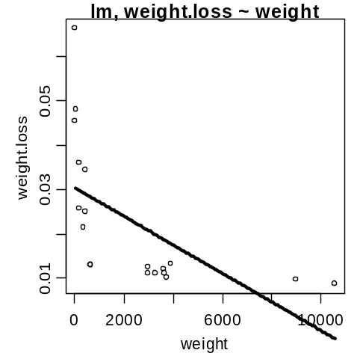
> plot.resid(lm1)
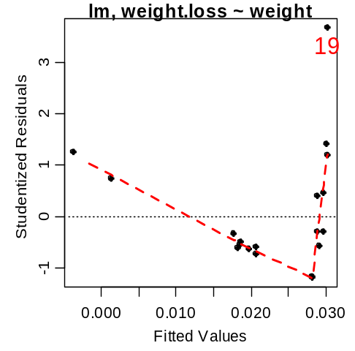
> max(weight)/min(weight) # max:min ratio >10
[1] 251.8333
> trans.chooser(lm1) # set lambda.x to 0 (log) and try lambda.y
> # I decided on log for y

> log.wt <- log(weight) # transform variables
> log.wtloss <- log(weight.loss)

> lm2 <- lm(log.wtloss~log.wt)
> plot.fit(lm2)
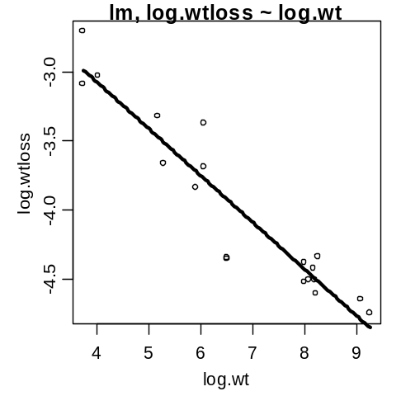
> plot.resid(lm2)
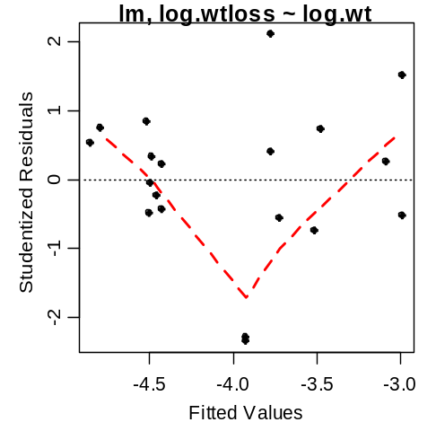

> ncv.test(lm2)
Non-constant Variance Score Test
Variance formula: ~ fitted.values
Chisquare = 0.8101365 Df = 1 p = 0.3680799

> ad.test(lm2$residuals)
Anderson-Darling normality test
data: lm2$residuals
A = 0.3881, p-value = 0.3514

> plot.diag(lm2)
1 predictors and 19 individuals

Unusual Observation Results
measure value cutoff inf obs
1 |Studentized Residuals| 2.34729 NA FALSE 10
2 Leverage 0.21118 0.31579 FALSE 18
3 |COVRATIO-1| 0.38230 0.31579 TRUE 18
4 Cook's Distance 0.28230 0.23529 TRUE 19
5 |DFFits| 0.77888 0.68599 TRUE 19
6 Slope DFBetas 0.25190 0.45883 FALSE 2
7 Intercept DFBetas 0.75053 0.45883 TRUE 19

Data for Highlighted Individuals
obs log.wtloss log.wt
18 18 -3.094448 3.737670
19 19 -2.713565 3.737670

> anova(lm2)
Analysis of Variance Table
Response: log.wtloss
Df Sum Sq Mean Sq F value Pr(>F)
log.wt 1 6.5113 6.5113 140.65 1.204e-09 ***
Residuals 17 0.7870 0.0463

> summary(lm2)
Call: lm(formula = log.wtloss ~ log.wt)
Coefficients:
Estimate Std. Error t value Pr(>|t|)
(Intercept) -1.73403 0.19792 -8.761 1.04e-07 ***
log.wt -0.33632 0.02836 -11.860 1.20e-09 ***

Residual standard error: 0.2152 on 17 degrees of freedom
Multiple R-Squared: 0.8922, Adjusted R-squared: 0.8858
F-statistic: 140.6 on 1 and 17 DF, p-value: 1.204e-09

> confint(lm2)
2.5 % 97.5 %
(Intercept) -2.1516113 -1.3164546
log.wt -0.3961507 -0.2764885

> p.log.wtloss <- predict(lm2,data.frame(log.wt=log(5000)),interval="c")
> exp(p.log.wtloss)*exp(anova(lm2)[2,3]/2)
fit lwr upr
[1,] 0.01030234 0.008884726 0.01194614

R Commands

library(NCStats)
library(MASS)
ss <- read.table(“SalmonSperm.txt”,head=T)
str(ss)
xlbl <- "Sperm Tail End Piece Length (um)" # to save typing later
ylbl <- "Fertilization Success"

plot(ss$fert.succ~ss$step.len,pch=19,col=as.numeric(ss$mat),xlab=xlbl, ylab=ylbl)
identify(ss$fert.succ~ss$step.len)
ss1 <- ss[-c(1,10,11),] # removed three outliers for simplicity
plot(ss1$fert.succ~ss1$step.len,pch=19,col=as.numeric(ss1$mat),xlab="Sperm Tail End Piece Length (um)",ylab="Fertilization Success")
attach(ss1)
lm1 <- lm(fert.succ~step.len)
summary(lm1)
plot.fit(lm1,xlab=xlbl,ylab=ylbl)
plot.fit(lm1,xlab=xlbl,ylab=ylbl,interval=”b”)
predict(lm1,data.frame(step.len=3.5))
predict(lm1,data.frame(step.len=3.5),interval=”c”)
predict(lm1,data.frame(step.len=3.5),interval=”p”)
plot.predict(lm1,data.frame(step.len=c(3.3,3.5)),interval="p",xlab=xlbl, ylab=ylbl)

anova(lm1)

plot.resid(lm1)
ncv.test(lm1)
ad.test(lm1$residuals)
hist(lm1$residuals)
outlier.test(lm1)
plot.diag(lm1)

library(NCStats)
library(MASS)
petrels <- read.csv("petrels.csv",head=T)
str(petrels)
attach(petrels)
xlbl <- "Weight (g)"
ylbl <- "Weight Loss (g/g/d)"
lm1 <- lm(weight.loss~weight)
plot.fit(lm1)
plot.resid(lm1)
max(weight)/min(weight) # max:min ratio >10
trans.chooser(lm1) # set lambda.x to 0 (log) and try lambda.y
# I decided on log for y
log.wt <- log(weight) # transform variables
log.wtloss <- log(weight.loss)

lm2 <- lm(log.wtloss~log.wt)
plot.fit(lm2)
plot.resid(lm2)
ncv.test(lm2)
ad.test(lm2$residuals)
plot.diag(lm2)

anova(lm2)
summary(lm2)
confint(lm2)

p.log.wtloss <- predict(lm2,data.frame(log.wt=log(5000)),interval="c")
exp(p.log.wtloss)*exp(anova(lm2)[2,3]/2)

